Jonathan Thorps

AWD1100 L01

**Introduction**

The goal of this software is to administrate employee access in and around a facility or building. While gates, locks, and full time security guards is would certainly address this, having a software solution as another layer of security would streamline assigning and revoking access. An electronic locking system backed with software that can administrate these privileges is also a better solution than having to issue out numerous physical keys. Certain individuals would have unrestricted access while others will have a limited access. Individuals will be categorized by what division they belong to. Assignment to departments would be permanent, while access privileges to different spaces can be modified as needed.

**Key Features**

Login

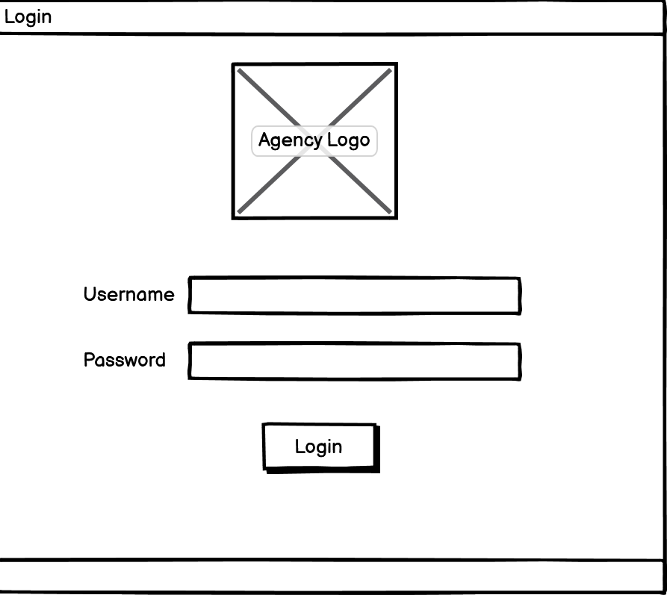To administer security access to badge holders on the system, there will be a login function in where administrators and security officers can control the creation and assignment of privileges. Upon successful login personnel will have the following functions:

* Search
* Create
* Update
* Delete

Search

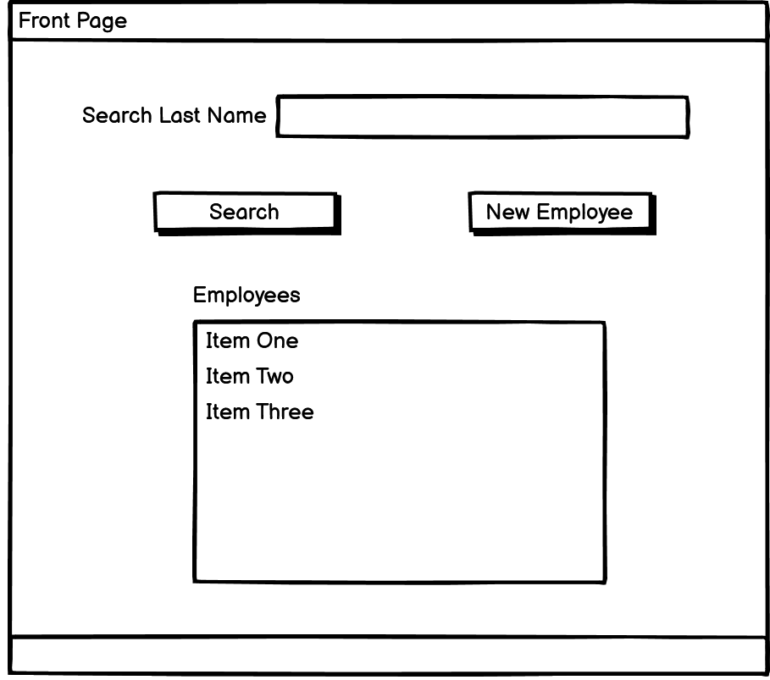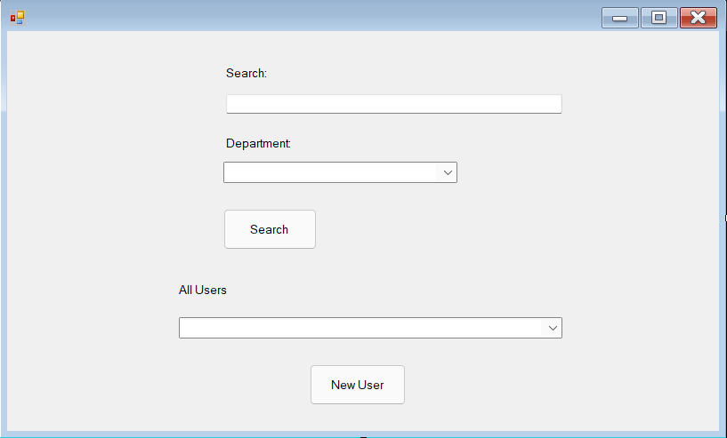

Add Employees

Security Officers will create new employees. Employees will have a unique numerical identifier assigned to them. At this screen users will have their access privileges assigned to them. Some privileges will be automatically assigned upon creation of a new employee.

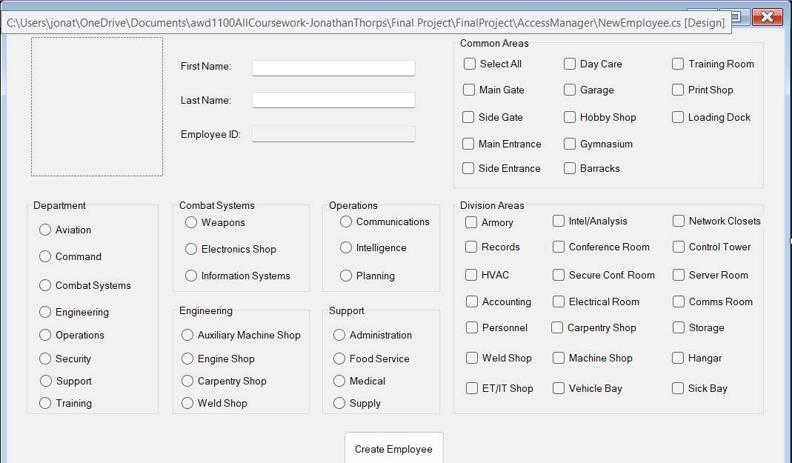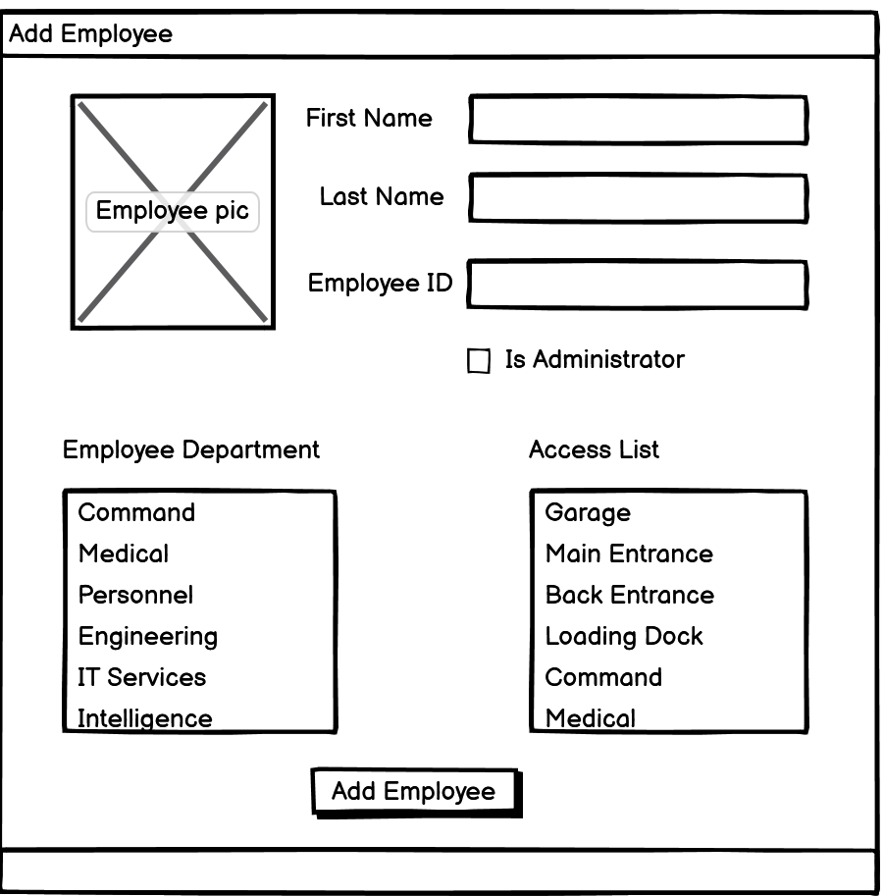

Update and Delete Users

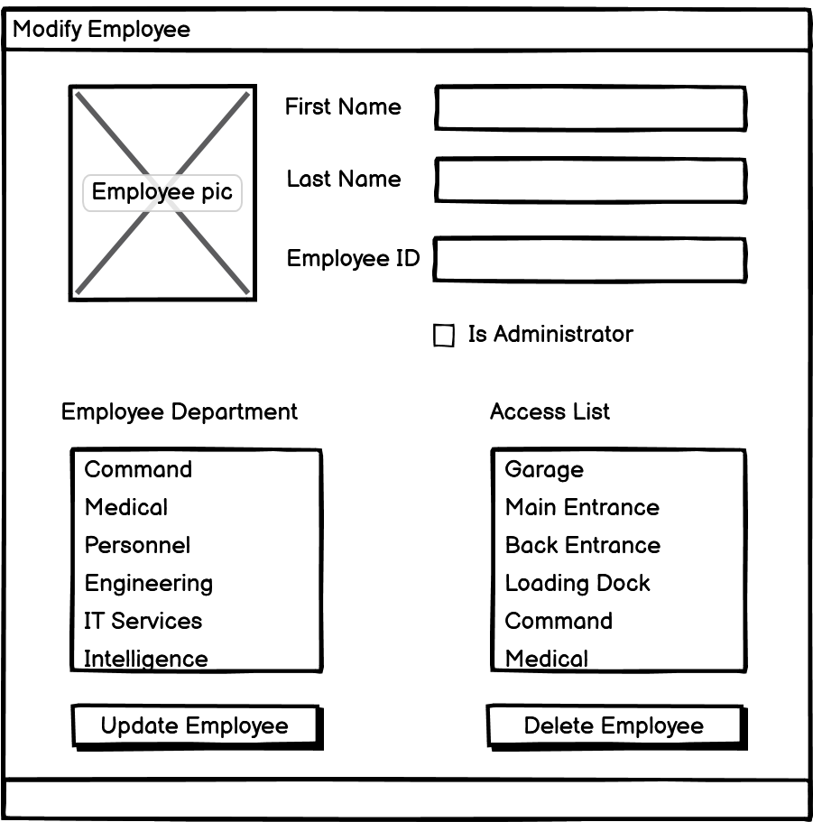

Security Officers will also have the ability to update employee access privileges. Additional access can be assigned or revoked. It is also here that employees can be deleted.

**Similar Software**

This type of software would be used in conjunction with a badge, RFID, and electronic lock system. Security officers would manage building access. Office space access would be divided into common spaces (i.e. library, cafeteria, conference room) and by division (Security, IT, Administration).

A software with similar capabilities is the security solution from Bosch.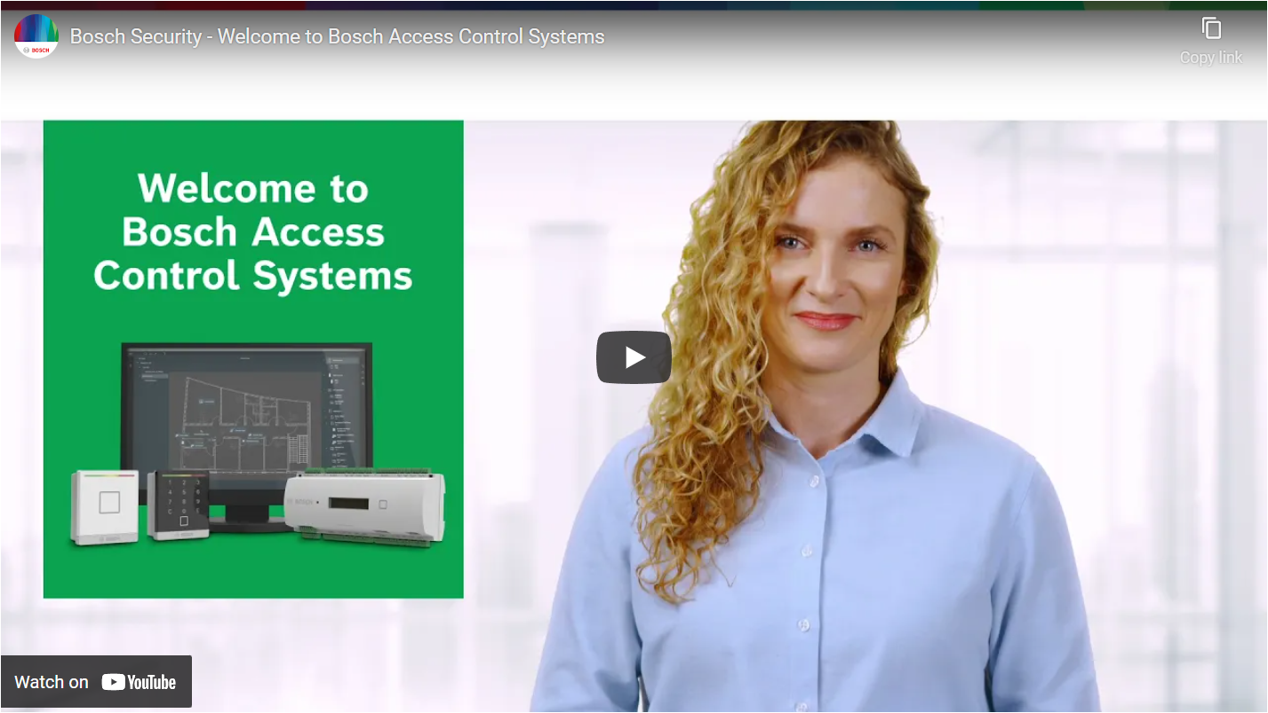 Their software can be scaled to a complete security suite integrating video surveillance and intrusion detection. Some of the available features are guest access, guard tour, and multi-factor authentication.

[Access Control Software | Bosch Security and Safety Systems I North America](https://www.boschsecurity.com/us/en/solutions/access-control-systems/access-control-software/)

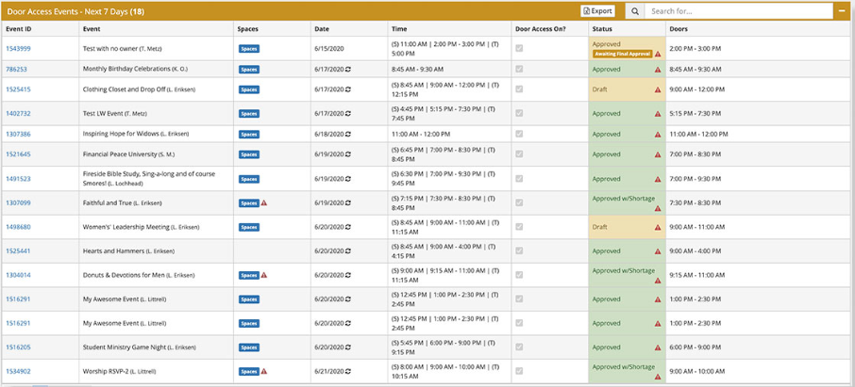

Smart Church Solutions also has a similar access control software. As seen in the picture above, Smart Church Solutions includes a logging feature for events that occur on the system.

[Security Access Control Software | Smart Church Solutions](https://www.smartchurchsolutions.com/software/facility-system-integrations/access-control/)